SOFTWARE REQUIREMENT SPECIFICATION
FOR
Student Management System
Under the Subject of
Software Engineering
(Semester – I)

Submitted by
- Rathod Daksh Sunilbhai (24002171210153)
- Patel Vrushti Alpeshbhai(24002171210130)
- Ghevariya Dhruv Arvindbhai(24002171510007)
- Panchal Neel Dineshbhai(24002171210103)
- Chauhan soniya Dharmendra sinh(24002171210029)

Mr. Kishan Pala
(Faculty Guide)

Ms. Khushbu Bhalodiya
(FY4-Head of Department)

Academic Year
2024 – 25


L. J. Institute of Engineering & Technology, Ahmedabad (LJU)

L. J. INSTITUTE OF ENGINEERING AND TECHNOLOGY
FY2-Department 2024 – 25

CERTIFICATE
Date:
This is to certify that the Software Engineering Work entitled “Title”, carried out by the group of students mentioned below under my guidance is approved for the Degree of Bachelor of Engineering (Semester-I) of L. J. Institute of Engineering and Technology (LJU) during the academic year 2023-24.

- Rathod Daksh Sunilbhai (24002171210153)
- Patel Vrushti Alpeshbhai(24002171210130)
- Ghevariya Dhruv Arvindbhai(24002171510007)
- Panchal Neel Dineshbhai (24002171210103)
- Chauhan Soniya Dharmendra (24002171210029)

Guide

Mr. Kishan Pala
FY4- Department, L.J.I.E.T.
Table of Contents
Sr. No. |  | Particulars |  | Page No.
1 |  | INTRODUCTION |  | 1
 | 1.1 | Purpose |  | 1
 | 1.2 | Scope |  | 1
 | 1.3 | Glossary |  | 1
 | 1.4 | Overview |  | 2
2 |  | OVERALL DESCRIPTION |  | 2
 | 2.1 | Problem Statement |  | 2
 | 2.2 | Existing System |  | 2
 | 2.3 | Proposed System |  | 3
 | 2.4 | Product Functions |  | 3
 | 2.5 | User Characteristics |  | 3
 |  | 2.5.1 User requirements |  | 4
 |  | 2.5.2 User Education Level |  | 4
 |  | 2.5.3 User’s Technical Expertise |  | 4
 | 2.6 | Constraints |  | 4
 | 2.7 | Assumption and Dependencies |  | 4
3 |  | REQUIREMENT SPECIFICATION |  | 4
 | 3.1 | Functional Requirements |  | 4
 |  | 3.1.1 Performance requirements |  | 4
 |  | 3.1.2 Design constraints |  | 4
 |  | 3.1.3 Hardware Requirements |  | 5
 |  | 3.1.4 Software Requirements |  | 5
 |  | 3.1.5 Other Requirement |  | 5
 | 3.2 | Non-Functional Requirements |  | 5
 |  | 3.2.1 Security |  | 5
 |  | 3.2.2 Reliability |  | 6
 |  | 3.2.3 Availability |  | 6
 |  | 3.2.4 Maintainability |  | 6
 |  | 3.2.5 Supportability |  | 7
4 |  | DIAGRAMS |  | 8
 | 4.1 | Use Case Diagram |  | 8
 | 4.2 | Data Flow Diagram |  | 9
 |  | 4.2.1 Level-0 DFD |  | 9
 |  | 4.2.2 Level-1 DFD |  | 10
 |  | 4.2.3 Level-2 DFD |  | 11
 | 4.3 | Activity Diagram |  | 12
 | 4.4 | Class Diagram |  | 13
 | 4.5 | Sequence Diagram |  | 15
5 |  | CONCLUSION |  | 17
6 |  | SCOPE OF THE PROJECT |  | 19

1. Introduction
1.1 Purpose
The purpose of this document is to define the functional and non-functional requirements for the development of a Student Management System. The system is designed to help educational institutions efficiently manage student information, including records and attendance. It allows administrators to add, update, remove, and search student information, mark attendance, and generate reports. This document will guide developers, testers, and stakeholders to ensure the system meets its functional and quality goals.
1.2 Scope
The Student Management System is a console-based application designed for educational institutions such as schools, colleges, and training centers. Its purpose is to streamline student information management and reduce errors associated with manual processes. Key functionalities include:
- Adding, removing, and updating student details.
- Searching for students by name or ID.
- Marking and viewing attendance records.
- Generating detailed attendance reports.
- Sorting students alphabetically.
- Filtering students by course.
The system is designed for administrators and aims to improve accuracy, save time, and reduce manual errors in student data management.
1.3 Glossary
- Student: A user of the system whose details (e.g., name, ID, course) are managed.
- Admin: The user responsible for managing student records and attendance.
- Attendance: A record of student presence or absence on a specific date.
- Report: A summary of a student’s attendance percentage.
- CRUD Operations: Create, Read, Update, and Delete actions performed on student records.
- Console-Based Application: A text-based interface run in a command-line environment.
1.4 Overview
The system is designed to be user-friendly, with intuitive menu-based navigation for CRUD operations on student records and attendance management. Implemented in Java, the system relies on arrays for data storage. The document covers system design, functional and non-functional requirements, diagrams, and conclusions.
2. Overall Description
2.1 Problem Statement
Many educational institutions rely on manual or spreadsheet-based methods for managing student information, which are prone to human error, inefficiencies, and limited reporting capabilities. There is a need for a more accurate, streamlined, and scalable system to manage student records and attendance efficiently. The system should simplify administrative tasks, enhance data accessibility, and provide reliable student reports and attendance tracking.
2.2 Existing System
The current methods involve either manual record-keeping or using basic spreadsheet applications. These methods come with significant limitations:
- Data Inaccuracy: High potential for data entry errors or duplication.
- Inefficiency: Managing student information manually takes excessive time and effort.
- Limited Functionality: Reporting, filtering, and tracking features are minimal or absent.
- Scalability Issues: Expansion of records or additional features requires manual adjustments.

2.3 Proposed System
The proposed system is a Java-based Student Management System that automates student data and attendance management. It provides the following key features:
- Student Records Management: Add, update, remove, and view student details.
- Attendance Tracking: Mark attendance for students by date and view attendance records.
- Search Functionality: Search students by name or ID.
- Sorting and Filtering: Sort students by name and filter them by enrolled courses.
- Attendance Report: Generate attendance percentage reports for each student.
- Scalability: The system is designed to accommodate additional features and functionality as needed.
2.4 Product Functions
The system provides the following core functionalities:
- Add Student: Add a new student with details like name, address, ID, and course.
- Remove Student: Remove a student using their ID.
- Update Student: Update student information.
- Search Student: Search for a student by name or ID.
- Mark Attendance: Record attendance for a student on a specific date.
- View Attendance: Display attendance records for a student.
- Generate Attendance Report: Calculate and display attendance percentages for students.
- Sort Students: Sort student records alphabetically.
- Filter Students: Filter students based on their course.
2.5 User Characteristics
2.5.1 User Requirements:
- Users should be able to manage student records and attendance easily.
- Users should have access to attendance reports and be able to search for students efficiently.
2.5.2 User Education Level:
- Basic computer literacy is sufficient.
2.5.3 User’s Technical Expertise:
- Familiarity with console-based applications and menu-driven interfaces is expected.
2.6 Constraints
- Attendance records are limited to a maximum of 30 days.
- No persistent storage; data is lost upon system termination.
- The system is designed for small to medium-sized institutions with up to 1,000 students.
2.7 Assumptions and Dependencies
- Assumes valid user inputs.
- Requires a Java Runtime Environment (JRE).
- Users should have basic knowledge of managing student records.
3. Requirement Specification
3.1 Functional Requirements
- Handle up to 1,000 student records efficiently.
- Complete key tasks, such as attendance marking and report generation, within 2 seconds.
3.1.2 Design Constraints
- Java Implementation: The system must be implemented in Java for platform independence.
- Data Storage using Arrays: Data is stored using fixed-size arrays for simplicity.
3.1.3 Hardware Requirements
- Processor: Dual-Core 2.0 GHz or higher
- RAM: 2 GB
- Storage: 500 MB of available disk space (for temporary file storage if persistent storage is added in the future)
- Graphics: Integrated Graphics capable of handling a console-based interface
- Display Resolution: 1024 x 768 resolution or higher

3.1.4 Software Requirements
- Operating System: Windows, macOS, Linux, or any Java-supported OS.
- Java Development Kit (JDK): Version 8 or higher.
- Java Runtime Environment (JRE): Required to execute the application.
- Text Editor/IDE: Any IDE that supports Java, such as Eclipse, IntelliJ IDEA, or NetBeans.
- Command-Line Interface (CLI): A terminal or command prompt to run the application.
3.1.5 User Interface Requirements
- Console-based menu-driven interface.
- User prompts for clear navigation and instructions.
- Error handling to provide meaningful error messages for invalid inputs.
3.2 Non-Functional Requirements
3.2.1 Security:
- Basic Validation:
Since the system does not manage sensitive data, it employs basic validation to ensure that user inputs are appropriate (e.g., valid student IDs, attendance status as "Present" or "Absent," non-empty names).
- Error Handling:
The system prevents common issues such as duplicate student IDs or invalid dates to maintain data integrity.
- Access Control:
While no authentication mechanism is currently implemented, the system assumes that only authorized users (e.g., admins) have access to the console environment.
    - Reliability:
- Input Handling:
The system handles invalid inputs gracefully, ensuring that it does not crash or terminate unexpectedly. Meaningful error messages are displayed for incorrect or incomplete data entries.
- System Stability:
All core operations (e.g., adding students, marking attendance) are tested to avoid unexpected crashes or data corruption.
- Data Consistency:
Ensures that student records and attendance are kept accurate, preventing duplicate or erroneous entries.
- Validation:
Verifies user inputs for operations like removing students (ensures student ID exists) or generating reports.
3.2.3 Availability:
- Offline Operation:
The system is entirely self-contained and can run as long as the Java runtime is installed, without needing external services or internet connections.
- Multi-Platform Support:
The system runs on any Java-supported operating system (e.g., Windows, macOS, Linux), ensuring high availability across different environments.
- Robust Runtime Behavior:
The application remains responsive during all typical operations, such as attendance marking, student record searches, or report generation.
3.2.4 Maintainability:
- Modularity: Each major operation is implemented as a separate method in the Student class.
- Inline comments: Detailed comments are provided for each method to ensure maintainability.
3.2.5 Supportability:
- Future storage options: The system can be extended to use file-based or database storage.
- GUI enhancement: Future iterations can include a graphical interface for better user experience.
- Additional features: New features, such as grading and scheduling, can be added as needed.

4. Diagrams
4.1 Use Case Diagram
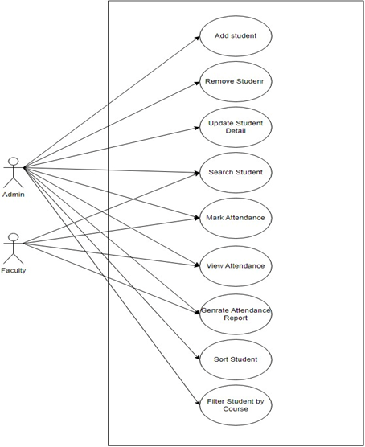
This Use Case Diagram for a Student Management System shows:
- Admin – Has full control over student-related operations.
- Faculty – Primarily involved in attendance management and reporting.

4.2 Data Flow Diagram (DFD)
4.2.1 Level-0 DFD:

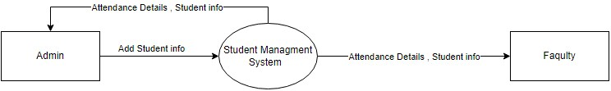
This diagram represents a Context-Level Data Flow Diagram (DFD) for a Student Management System (SMS). It illustrates the external entities interacting with the system:
- Admin: Provides input and manages student data and system operations.
- Faculty: Interacts with the system to update student attendance or retrieve data.

4.2.2 Level-1 DFD:
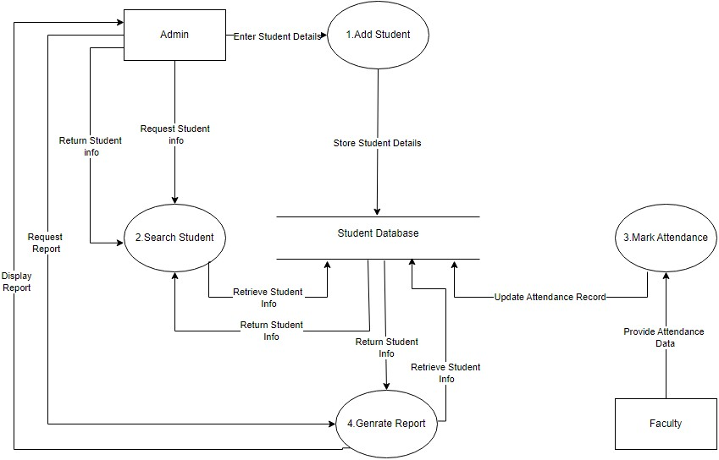
This Level 1 Data Flow Diagram (DFD) for a Student Management System shows the flow of data between the system, actors, and processes:
- Add Student: Admin adds student details, which are stored in the student database.
- Search Student: Admin requests student information, and the database returns the data.
- Mark Attendance: Faculty updates student attendance in the database.
- Generate Report: Admin requests a report, which is generated using student data.
- View Attendance: Students can retrieve their attendance records from the database.
The student database acts as the central data store, connecting all processes and external entity.

4.2.3 Level-2 DFD:
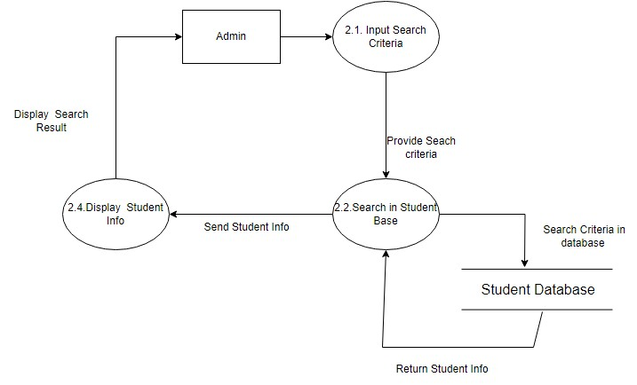

This expanded Level 2 Data Flow Diagram (DFD) focuses on the "Search Student" process:
- 2.1 Input Search Criteria: Admin provides search criteria (e.g., student name or ID).
- 2.2 Search in Student Base: The system searches the student database using the provided criteria.
- Student Database: The database returns matching student information.
- 2.4 Display Student Info: The system displays the search results to the admin.
This detailed process shows the flow of data from input to the display of search results, with the student database as the central data source.

4.3 Activity Diagram
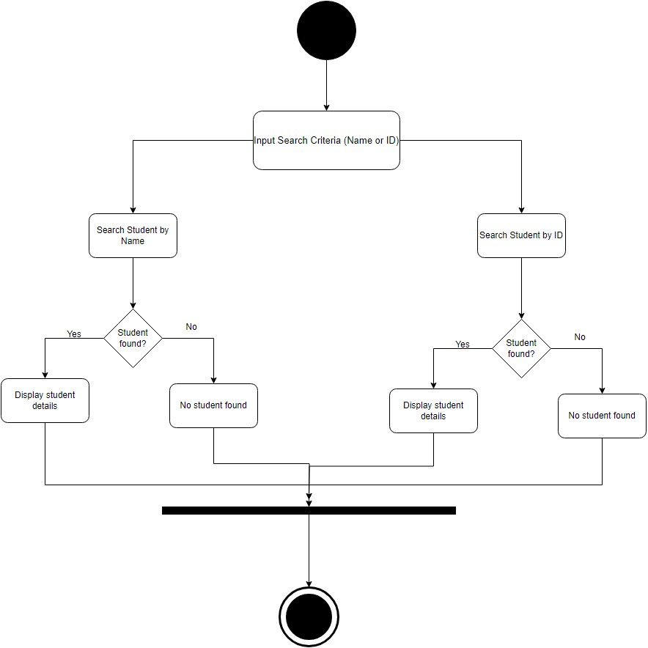
This Activity daigram illustrates the Search Student Process based on input criteria:
- Input Search Criteria: The user enters search criteria (name or ID).
- Search by Name: If searching by name:
  - If the student is found, their details are displayed.
  - If not found, a "No student found" message is shown.
- Search by ID: If searching by ID:
  - If the student is found, their details are displayed.
  - If not found, a "No student found" message is shown.
The Activity daigram ensures both search methods are handled independently but result in displaying appropriate outcomes

4.4 Class Diagram
- Main Class: Manages the main menu and user interactions.
- Student Class: Manages student attributes, attendance, and report generation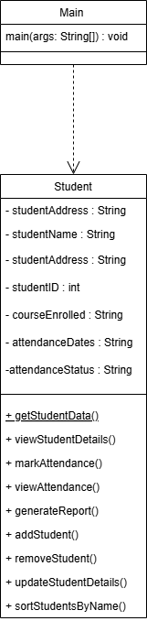

This class diagram represents a Student class in a Student Management System:
Attributes:
- studentName: Stores the name of the student.
- studentAddress: Holds the address of the student.
- studentID: A unique identifier for the student.
- courseEnrolled: The course in which the student is enrolled.
- attendanceDates: A list of dates marking the student's attendance.
- attendanceStatus: Tracks attendance status for the corresponding dates.
- currentIndex: A pointer or index to manage attendance records.
Methods:
- getStudentData(): Retrieves all student data.
- viewStudentDetails(): Displays student details.
- markAttendance(): Marks the student’s attendance for a given date.
- viewAttendance(): Allows viewing the student’s attendance record.
- generateReport(): Creates a detailed student performance or attendance report.
- addStudent(): Adds a new student record.
- removeStudent(): Removes an existing student record.
- updateStudentDetails(): Updates a student’s information.
- sortStudentsByName(): Sorts the list of students alphabetically by name.
This design provides comprehensive functionality for student management, covering data retrieval, attendance, student records management, and reporting.

4.5 Sequence Diagram
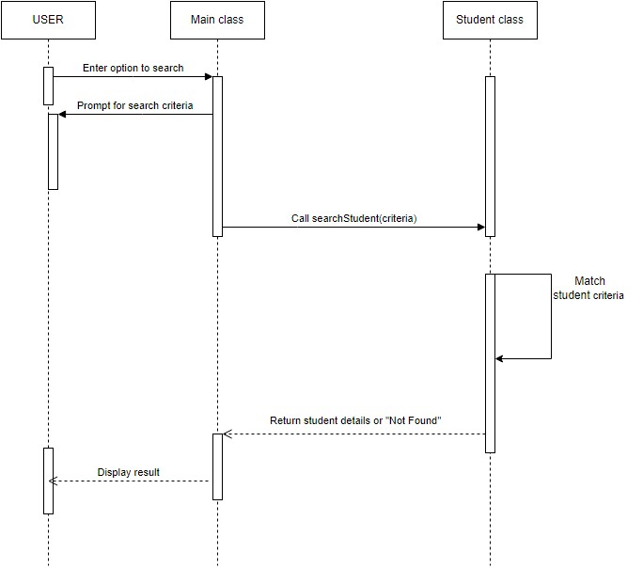

This sequence diagram illustrates the search student process in a student management system:
- User:
  - Enters the option to search.
  - The system prompts the user to input search criteria.
- Main Class:
  - Receives the search criteria and calls searchStudent(criteria) in the Student Class.
- Student Class:
  - Matches the search criteria with the student records.
  - Returns the student details if a match is found or "Not Found" if no match exists.
- Main Class:
  - Displays the search result (either student details or a "Not Found" message) to the user.
This diagram demonstrates a simple interaction flow for searching and retrieving student details.

5. Conclusion
The Student Management System is designed to provide an efficient, user-friendly solution for educational institutions to manage student information and attendance records. By automating manual tasks like adding, updating, removing, and searching for student details, this system helps reduce errors and improve overall accuracy. The ability to mark and generate attendance reports further enhances administrative efficiency.
Key benefits of this system include:
- Time Efficiency: Automating repetitive administrative tasks reduces the time spent on student record management.
- Error Reduction: Input validation and meaningful error messages help reduce common mistakes.
- Data Organization: Sorting and filtering features provide a streamlined view of student records, aiding quick decision-making.
- Scalability: Although currently limited to console-based functionality, the system is designed with modularity to allow easy future enhancements.
- User-Friendliness: The console-based, menu-driven interface ensures that users with basic computer knowledge can easily navigate and perform all operations.
Overall, this system offers a foundational framework for student data management and serves as a stepping stone for future developments like persistent storage, advanced reporting, and graphical interfaces.

6. Scope of the Project
This project focuses on developing a Java-based, console-driven Student Management System that addresses the core needs of educational administrators. The following areas are covered in the current implementation:
- Core Features: Adding, updating, removing, and searching student records.
- Attendance Management: Marking attendance, viewing records, and generating attendance percentage reports.
- Data Display: Sorting and filtering student data by name and course.
- User Experience: Simple menu-driven navigation to guide users through various operations.
Future Development Potential
While the current version is functional and efficient for small- to medium-sized institutions, the system has several opportunities for future enhancements, including:
- Persistent Storage:
  - Add file-based storage or database integration to retain student and attendance records beyond program termination.
  - Implement backup and restore functionalities to safeguard data.
- Graphical User Interface (GUI):
  - Upgrade the system to a graphical interface to improve user experience with buttons, tables, and drop-down menus for easier interaction.
- Advanced Reporting:
  - Enable advanced reporting features such as detailed breakdowns of attendance by month or course.
  - Introduce export options (e.g., PDF, Excel) for reports.
- Security Enhancements:
  - Add role-based access control to limit access to sensitive data and functions (e.g., admin-only privileges).
  - Implement login authentication for added data protection.
- Grading and Academic Records:
  - Expand the system to manage student grades and academic performance.
  - Include grade-based reports and progress tracking features.
- Notifications and Alerts:
  - Integrate automated email or SMS notifications for attendance reminders or low attendance warnings.
- Scheduling:
  - Add scheduling features for classes, exams, and events to help administrators manage institutional calendars.
Long-Term Vision
The ultimate goal is to transform this basic student management tool into a comprehensive, full-featured Student Information System (SIS) that supports persistent data storage, multi-user access, advanced reporting, and an intuitive GUI. These future developments will further improve the overall efficiency, accessibility, and reliability of the system, making it a valuable tool for educational institutions of all sizes.

